Exercise 4: Arrange-Act-Assert (AAA) Pattern, Test Fixtures, Setup and Teardown Methods in JUnit
This document covers the steps I followed to complete Exercise 4, where the goal was to organize tests using the Arrange-Act-Assert (AAA) pattern, and to use the @Before and @After annotations to handle setup and teardown around each test.

What I Did
I created a new test class called AAAPatternTest in the same org.example package used for the earlier exercises. Inside it, I wrote two test methods, testAddition() and testSubtraction(), and structured each one clearly into three parts:
- Arrange – set up the values needed for the test (in this case, the expected result)
- Act – perform the actual operation being tested (addition or subtraction)
- Assert – check that the actual result matches what was expected
To avoid repeating the same initialization code in every test, I used @Before to write a setUp() method that runs automatically before each test, initializing two instance variables, a and b. Similarly, I used @After to write a tearDown() method that runs automatically after each test, resetting those variables back to zero and printing a cleanup message.
Because @Before and @After run around every single test method (not just once for the whole class), setUp() and tearDown() each execute once per test, ensuring every test starts and ends in a clean, predictable state.

Test Code
The final AAAPatternTest.java file looks like this:
package org.example;

import org.junit.After;
import org.junit.Before;
import org.junit.Test;
import static org.junit.Assert.assertEquals;

public class AAAPatternTest {

private int a;
private int b;

@Before
public void setUp() {
// Runs before every test method
System.out.println("Setup: initializing values before test...");
a = 10;
b = 5;
}

@Test
public void testAddition() {
// Arrange
int expected = 15;

// Act
int actual = a + b;

// Assert
assertEquals(expected, actual);
}

@Test
public void testSubtraction() {
// Arrange
int expected = 5;

// Act
int actual = a - b;

// Assert
assertEquals(expected, actual);
}

@After
public void tearDown() {
// Runs after every test method
System.out.println("Teardown: cleaning up after test...");
a = 0;
b = 0;
}
}

Running the Test
I ran the testSubtraction() test from IntelliJ IDEA, and the Run panel confirmed the setup and teardown methods executed correctly around it:
- testSubtraction shows a green checkmark, and the summary reads "1 test passed"
- The console printed "Setup: initializing values before test..." before the test ran
- The console printed "Teardown: cleaning up after test..." right after the test finished
- The process finished with exit code 0
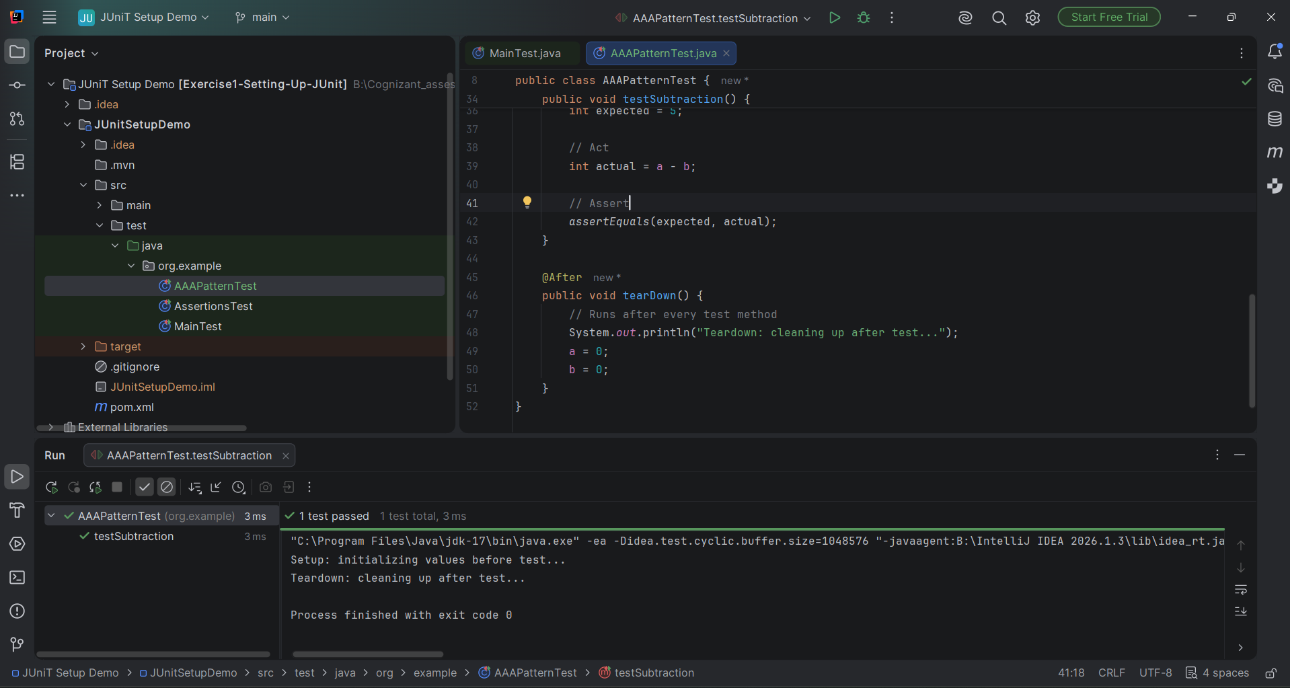

Result
The test passed successfully, and the console output confirms that setUp() ran before the test and tearDown() ran after it, exactly as expected with @Before and @After. This shows the AAA pattern and JUnit fixtures working correctly together, and completes Exercise 4 successfully.

